**Execrise -3**

**Macropack:**

Installing the macropack:

Packing the payload:

Full screenshot:

**Packmypayload:**

Installing the packmypayload:

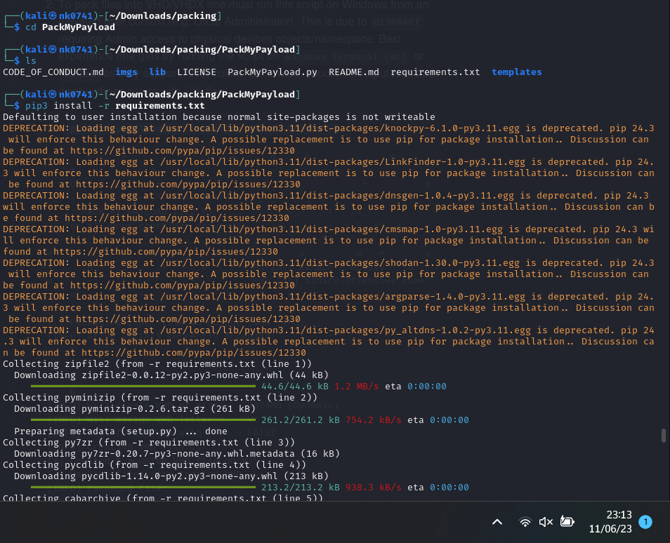

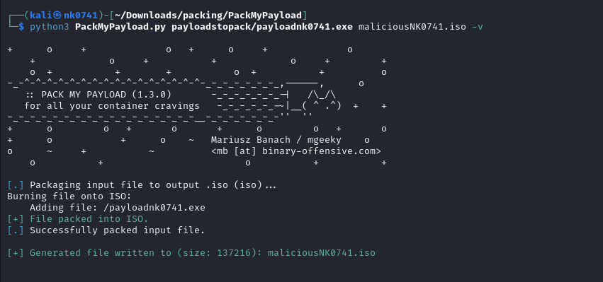

Successfully created the payload using packmypayload in .iso format.

Full screenshot with time:

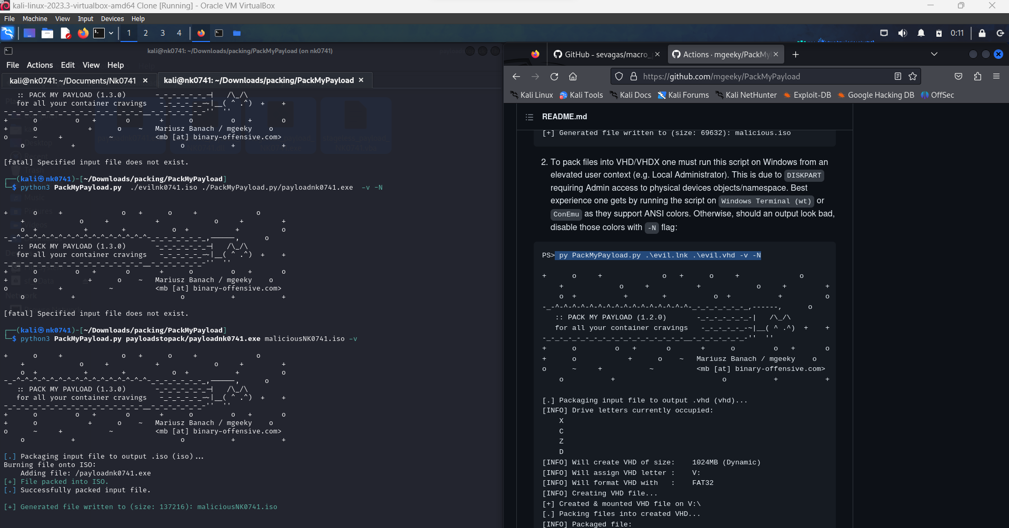

I have attached the packed payload as well.

For macropack we packed it into .docx format and for packmypayload we used .iso formats